E File: Probs-Ch8.doc
Chapter 8:

Problems: Pythagorean Theorem and Perimeter

This file contains a selection of problems related to Chapter 8. These may be used when making up exams.

Area-Side Relationships

- If the area of a square is 144, how long is a side?

- If the area of a square is 14, how long is a side?

- If the area of a square is 16, how long is the diagonal?

- Find the length of this slanted length by making a square and figuring its area. Show your work!


Triangle of Squares

- For the triangle drawn below, carefully form a triangle of squares. Write its area in each square. Is the triangle a right triangle? Yes or No
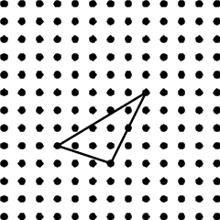

- For each side of the right triangle below circle two points which will complete a square on that side. This will form a right triangle of squares. Write the area inside each of these squares.
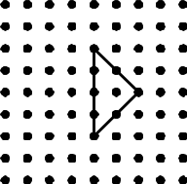

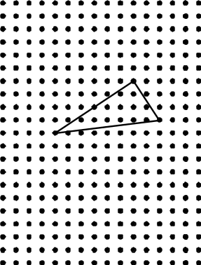
Alternate Figures for two previous problems: (Careful! Some are NOT right triangles)
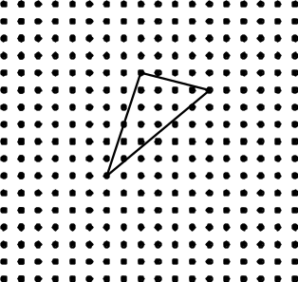

- Consider this figure.
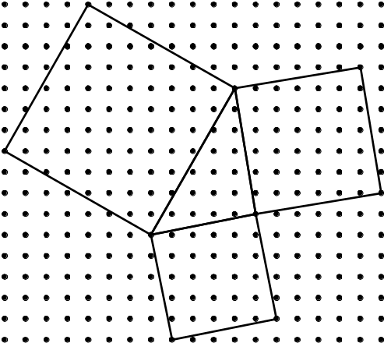

  - Is this a right triangle of squares (Yes or No)?

  - Give two different reasons for your answer.

Reason 1:

Reason 2:

- If you put these three squares together, would they form a right triangle of squares?
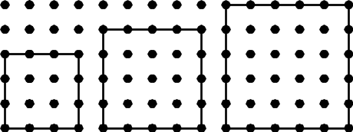

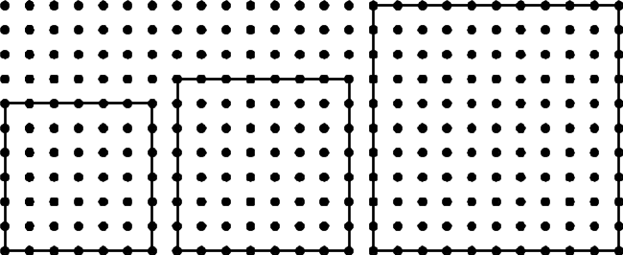
Alternate Figures:

Perimeter Problems

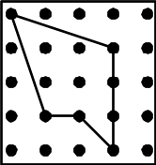
- Find the perimeter of the following figure. Express your answer in two ways.

(a) The perimeter as a sum of square roots.

(b) The perimeter as a decimal.

- Make up two noncongruent polygons with perimeter 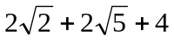
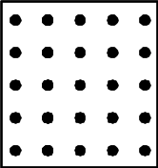
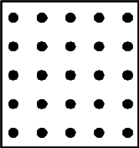

- What is the perimeter of the pentagon pictured below?
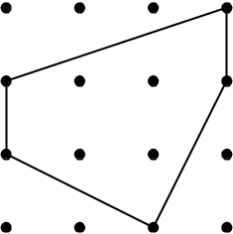

Express your answer:
- As a sum of square roots:

- As a decimal:

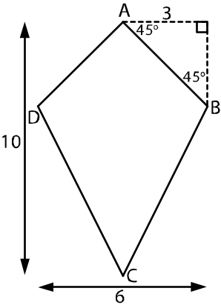
- What is the perimeter of the kite ABCD shown below?

- What is the perimeter of the quadrilateral pictured below? Express your answer
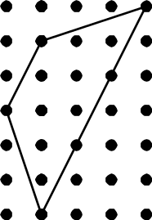
- as a sum of square roots

- as a decimal

- What is the perimeter of triangle ABC?
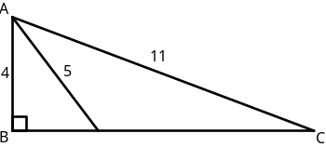

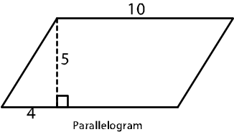
- What is the perimeter of the parallelogram shown below where one side is 10 meters, the altitude is 5 meters and the foot of the altitude is 4 meters from one end?

Pythagorean Theorem Problems

- Find the lengths of the unmarked sides of these triangles.
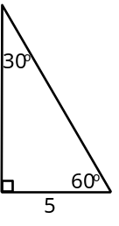
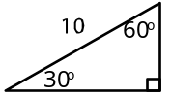

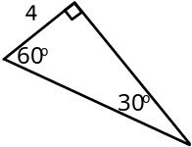
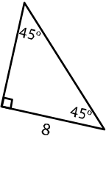
Alternate figures:
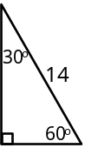
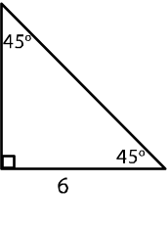

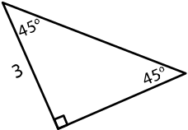

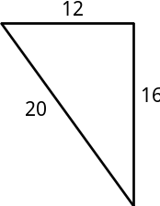
- Below are given a variety of triangles, circle those that are right triangles.
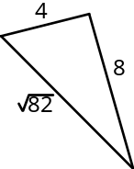

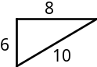

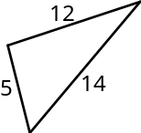
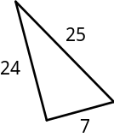
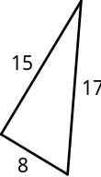
Alternate Figures:
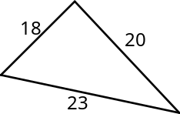

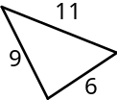

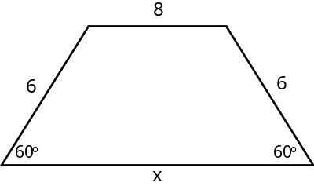
- How long is the side marked x of the isosceles trapezoid given below?

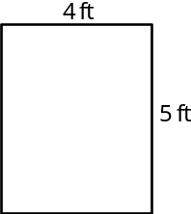
- Does Jim Fit? If Jim is 6 feet tall, will he fit on a bed that measures 3 feet by 4 feet? (OR 4 feet by 5 feet)
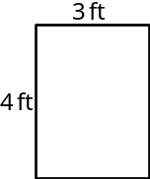
OR

- An electric pole which was broken in a tornado is shown below. The electric pole measures 10 feet from the base to the break. The distance along the ground between the base and where the tip touches the ground is 40 feet. How tall was the pole originally? Give your answer as both a square root and as a decimal.
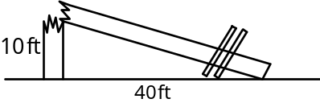

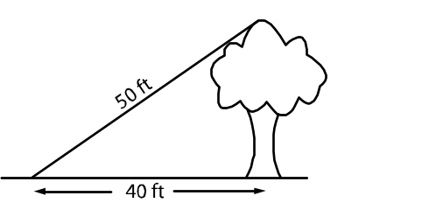
- An oak tree casts a shadow that is 10 feet long. The distance from the top of the tree to the end of the shadow is 50 feet. How tall is the tree?

- Assume you are driving from point Q to point R. Approximately how much further do you have to drive if you go from Q to P and then from P to R than if you go directly from Q to R? (Triangle PQR is a right triangle.)
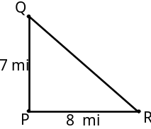

- A picture frame is 22 inches wide. A string, which is 28 inches long, goes from one corner of the frame to the other above the top as shown. If the picture hangs on a hook as shown, how far will it be from the hook down to the top of the frame?
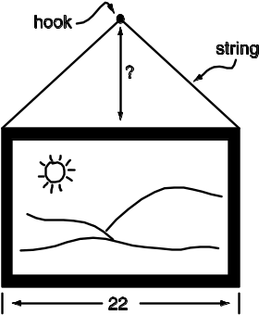

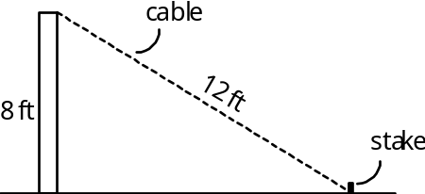
- Jan wants to attach a cable that is 12 feet long to the top of a pole which is 8 feet high. She will stretch out the cable and attach it to a stake in the ground as shown. How far will it be from the base of the pole to the stake? (Express your answer in two ways: as a square root and as a decimal.)

- Mark and Mary are flying a kite. Mark has let out 120 feet of string and the kite is directly above Mary’s head. Mary is 90 feet away from Mark. How far above Mary’s head is the kite? Be sure to show your computations.
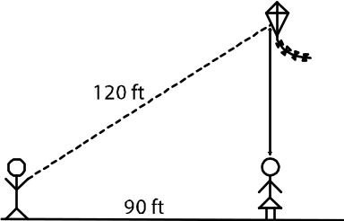

- If a rope goes from the top of a building which is 50 feet tall to the top of a 20 foot pole which is located 60 feet from the building, how long does the rope need to be?

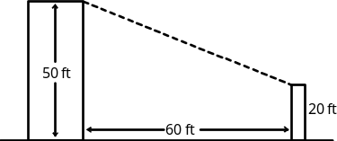

- Jamie attaches one end of a 12-foot chain to her dog Bowzer’s collar and the other end to the top of a stake which is 6 feet tall. Bowzer’s collar is one foot off the ground. If Bowzer pulls the chain tight, how far can she get from the stake?
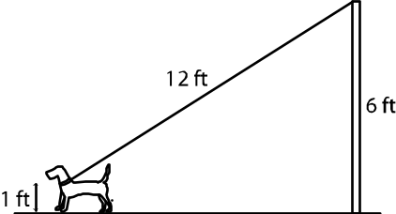

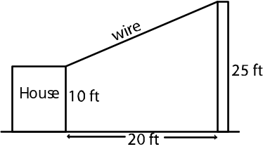
- Wire runs from the top of a 25 foot pole to the corner of a house which is 10 feet tall. Mary measures the distance between the bottom of the building to the base of the pole as 20 feet. How long is the wire?

- A 25-foot ladder reaches 24 feet up the side of a building. How far is the bottom of the ladder from the base of the building?
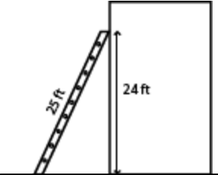

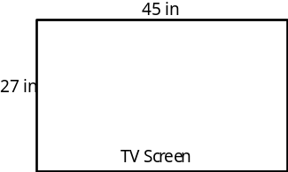
- Jones bought a new wide screen high definition TV. The rectangular screen measures 27 in. by 45 in. wide. However, when TVs are advertised their size is the diagonal length of the screen. What is the advertised size of Jones’s new TV?

- A faucet is located at one corner of a yard that measures 50 feet by 65 feet. How long must a garden hose be in order to be able to water plants in any part of the yard? Round your answer to the nearest foot.
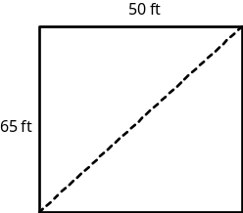

- A rectangular field measures 325 meters by 240 meters. How much shorter would it be to walk diagonally across the field than to walk around two sides of the field. Round your answer to the nearest meter.
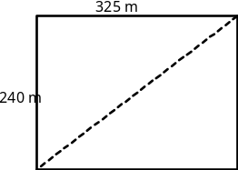

- Flags have been placed at points X and Y on opposite sides of a small pond. Another flag was placed at point A so that a right triangle is formed at point Y (where lines YX and YA meet.) The length s of the ‘overland’ distance AX and AY were measured and marked on the map. How far is it across the pond from flag X to flag Y?
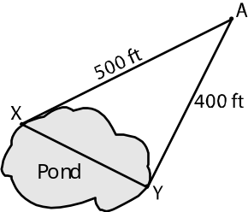

- Consider the following two triangles.
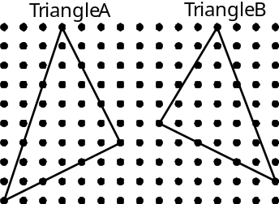

For each triangle, decide if it is a right triangle or not. Also, give your reasoning.
- Triangle A – Right triangle?: YES or NO
Reason:

- Triangle A – Right triangle?: YES or NO
Reason:

Finding Area
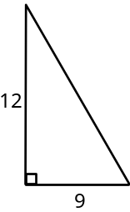
- Find the area of the following triangles.
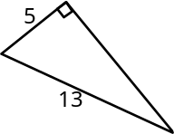

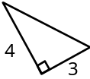
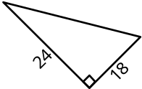
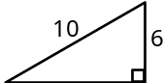
Alternate Figures:

- This figure shows the length of two diagonals of a rhombus. What is the area of the rhombus? Show your work!
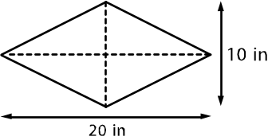

Miscellaneous

- If Sammy and Sally left the library at the same time, but Sammy following path A and Sally followed path B, who would reach the park first if they walked at the same speed?
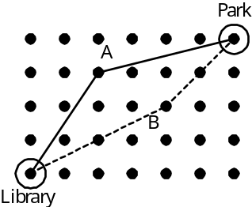

- Draw a line whose length is as follows, or state that it is not possible. If it is not possible, explain why.

(a) 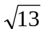
(b) 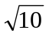
(c) 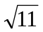

- Betty was trying to make up a diagonal line segment on a geoboard with length 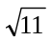. She was beginning to think that this was impossible.
If you disagree and think that this length is possible, draw an example on the dot paper below.

BUT, if you agree with Betty and think that this length is impossible, then give an explanation why the length is impossible on a geoboard.

- Find the length of this diagonal.


Alternate figures:
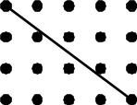



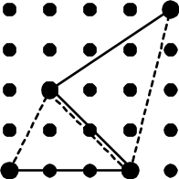
- Determine the shortest route from work to home if you must stop at both the library and the grocery store on the way. Calculate the distance for each of the two routes in the space below.

Route 1 - - - - - -

Route 2

- Find both the area and the perimeter of the quadrilateral below. Express the perimeter in terms of both square roots and decimals. Show your calculations!
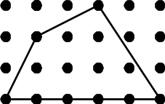
Area:

Perimeter:

- On the dot paper below there is a circle around one dot and a square around another.

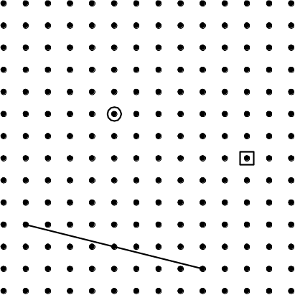

- First of all draw a circle around another dot so that the segment between the two circled dots is parallel to the given line segment.

- Secondly, draw a square around another dot so that the segment joining the two squared dots is perpendicular to the given line segment.

- (5 points) Circle the two dots which would make the corners of a square whose side is given below.
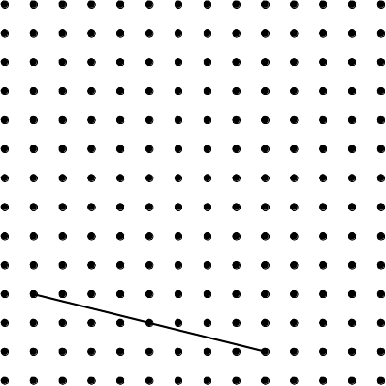


True or Not?

- For the following statements
    - If true, simply write true, or
    - If false, write false and draw an example
showing the statement is false.

    - In a triangle of squares, if you add the area of the two smaller squares, you will always get the area of the largest square.

- When finding the area of a right triangle, the length of the hypotenuse is the height.

    - Perimeter of geoboard figures is not always a whole number. (There can be decimals.)

Alternate statements:

- The area of any triangle is equal to the base multiplied by the height.

- The sides of a right triangle will always be related by 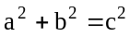.

- For a square on a geoboard, the sides must have a length of 1, 2, 3, or 4 units.

- If the side of a square has length 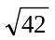, then the area is 42.

- In a 30-60-90 triangle, the longer leg is twice the length of the shorter leg.

- In a 45-45-90 triangle, the legs are always the same length.

Possible?

- For each of the following statements, decide if it is possible or not.
  - If it is possible, write POSSIBLE and draw a picture.
  - If it is not possible, write NOT and give a reason.


A triangle of squares where the triangle is not a right triangle.

A square that has side length 12 and area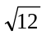.

A right triangle with sides 5, 7, and 12.

Alternate Statements:
A right triangle where the Pythagorean Theorem does not hold.

A slanted line on a geoboard with length 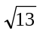.

A geoboard figure with perimeter equal to 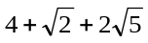.

A 45-45-90 triangle with sides 3, 4 , and 5.

A geoboard quadrilateral with perimeter equal to 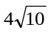.

A 30-60-90 triangle with sides 4, 8, and 8.94.

Conditions


- Write a complete and true sentence
containing the following statement and conditions under which it is true.
Statement: The side of the triangle are related by
a² + b² = c².

Your Sentence:

- Write a complete and true sentence
containing the following statement and conditions under which it is true.
Statement: When a triangle of squares is formed,
the areas of the two smallest squares added together give the area of the largest square.

Your Sentence:

- Write a complete and true sentence
containing the following statement and conditions under which it is true.
Statement: The area is the side length multiplied by itself.

Your Sentence:

- Write a complete and true sentence
containing the following statement and conditions under which it is true.
Statement: The hypotenuse is twice the length of the shorter leg.

Your Sentence:

- Write a complete and true sentence
containing the following statement and conditions under which it is true.
Statement: The area is ½ the legs multiplied by each other.

Your Sentence:

- Write a complete and true sentence
containing the following statement and conditions under which it is true.
Statement: The legs are equal in length .

Your Sentence:

- Write a complete and true sentence
containing the following statement and conditions under which it is true.
Statement: When a triangle of squares is formed,
the areas of the two smallest squares added together does not equal the area of the largest square.

Your Sentence:

- Write a complete and true sentence
containing the following statement and conditions under which it is true.
Statement: A geoboard segment which has a square root or decimal as its length.

Your Sentence:

- Write a complete and true sentence
containing the following statement and conditions under which it is true.
Statement: The triangle is exactly one-half of a square.

Your Sentence:

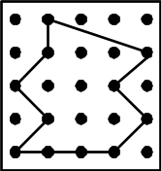
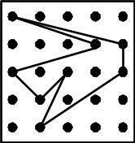
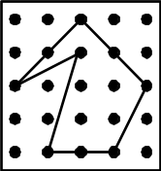
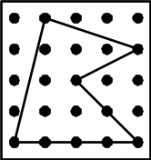
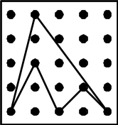
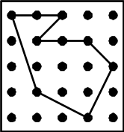
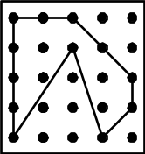
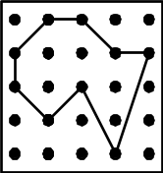
Alternate Geoboard figures:

