File: E04s-F.doc
Geometric Structures – Final – Spring 2004
Name:_______________________

- (15 points) Using the code table below, identify the symmetry type of these borders.

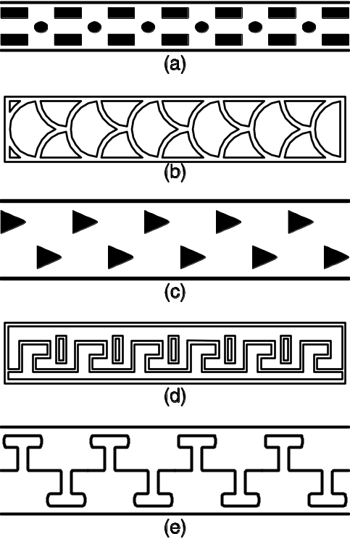

Code for Border Patterns
First | Second
m crossline sym. | m centerline sym.
1 no crossline sym. | g glide reflectional sym.
 | 2 half-turn symmetry
 | 1 no additional sym.

- (8 points) Four pairs of congruent figures are given below. Indicate which of the four types of actions relate the two copies by writing translation, rotation, reflection or glide reflection.
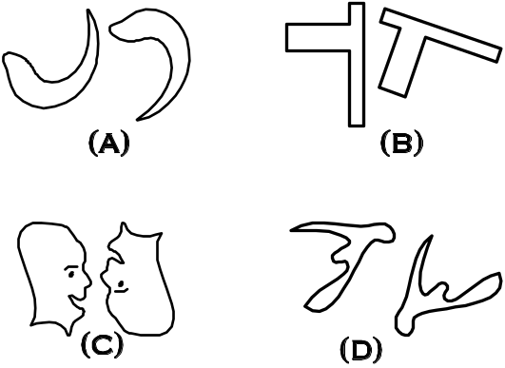

- (8 points-C) Figure out the area of the figure below showing your work. Then describe the process that you used.
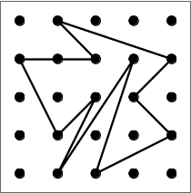

Describe the process:

- (10 points-C) One of the methods which we have been using to find the area of a geoboard figure is the following:
Method: The area is the number of inside pegs plus one, i.e.,
Area = (Inside Pegs) + 1.

- On the geoboard below make up an example where this methods works for finding the area.

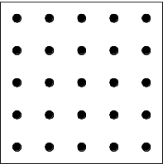

- Describe the conditions on a geoboard figure for this method to work. Your Description:

- On the geoboard below make up an example where the method above does not work.

- (9 points) What is the measure of each of the interior angles if a regular septagon? Note: One of the interior angles is marked with an x in the figure below. You are both to show your calculation and also to describe in words your reasoning.
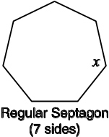
- Show your calculation.

- Write out in words your reasoning.
Your reasoning:

- (12 points-C) In the figure below for each of the angles marked with a letter, (i) give the value of the angle and (ii) give a reason.

Acceptable reasons include:
“alternate interior angle to something”
“corresponding angle to something”
“vertical angle to something”
“supplementary angle to something” or
“the angle sum is something.”
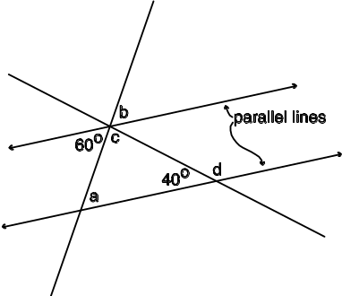
- The value of a is:
The reason is:

- The value of b is:
The reason is:

- The value of c is:
The reason is:

- The value of d is:
The reason is:
- (9 points) Mark and Mary are flying a kite. Mark has let out 120 feet of string and the kite is directly above Mary’s head. Mary is 90 feet away from Mark.
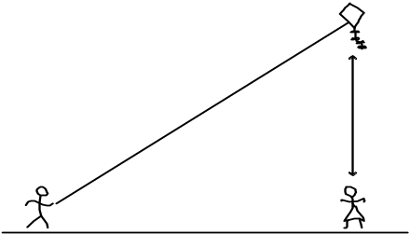

How far is the kite above Mary’s head? Be sure to show your computations.

- (8 points-C) Find the perimeter of the geoboard figure given below. Express your answer in the two ways asked for.
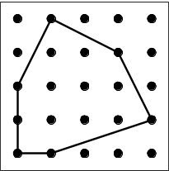

- The perimeter expressed as a sum of square roots.

- The perimeter expressed as a decimal.

- (5 points-C) If the triangle pictured below were stood up with its base AB flat on the floor, how tall would it be? (Show your reasoning.)

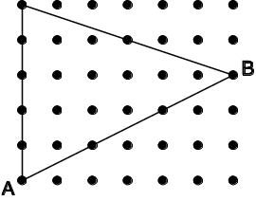

- (8 points-C) What is the perimeter of triangle ABC?

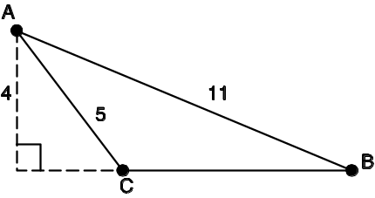

- (8 points) A right prism is shown below which has a square base and a height of 12. What is its volume?
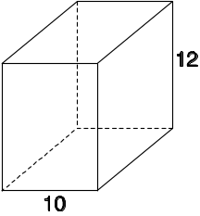

- (7 points) A pyramid is pictured below with a square base. What is the volume of this pyramid? Be sure to show your work!
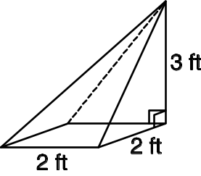

- (7 points) For this problem you are to give two possible definitions for a fold and cut shape. First examine these two groups of figures.
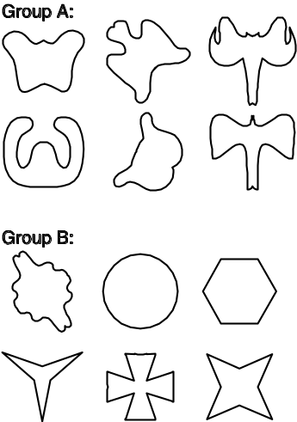
- Give a definition of “fold and cut shape” so that Group A satisfies the definition but Group B does not. Your definition:

- Give a more inclusive definition of “fold and cut shape” so that both Group A and Group B satisfy the definition. Your definition:

- (7 points-C) Two properties of kites are given below. You are to decide if they are defining properties or not (if not then draw a counterexample). The following display of “test” examples may help with your decision.
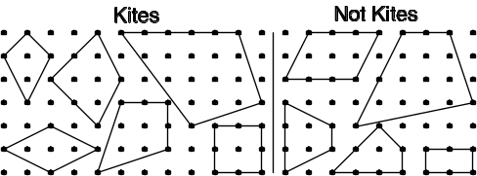

(a) Property: A kite is a quadrilateral where one or
more diagonals are lines of symmetry.
Defining Property? YES NO
If NO then give counterexample:

(b) Property: A kite is a quadrilateral with
perpendicular diagonals.
Defining Property? YES NO
If NO then give counterexample:

- (7 points-C) We have been considering the seven types of quadrilaterals shown here.
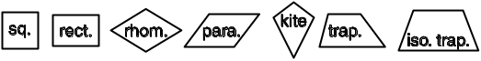
- If we think of inclusive definitions for these shapes, which of these seven are special cases of a parallelogram?

- Which of the seven are special cases of a kite?

- (8 Points) The two figures below are similar. Inside of each figure write the area.

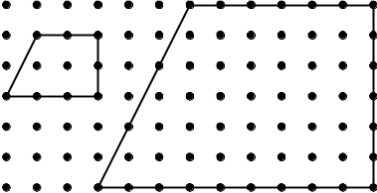

- What is the scale factor going from the smaller figure to the larger?

- What is the area factor going from the smaller figure to the larger?

- Describe the relationship between the area factor and the scale factor. Your description:

- (8 points) Max is planning to enlarge his square cattle pasture so that the new fence encloses two times the area of the present pasture. He wants the pasture to remain square. The original fence is 200 feet long on each side. How long does one side of the new fence need to be?

- (12 points) Analyze each of the Escher style tessellations given below. For each design, indicate the Heesch type.

(a) 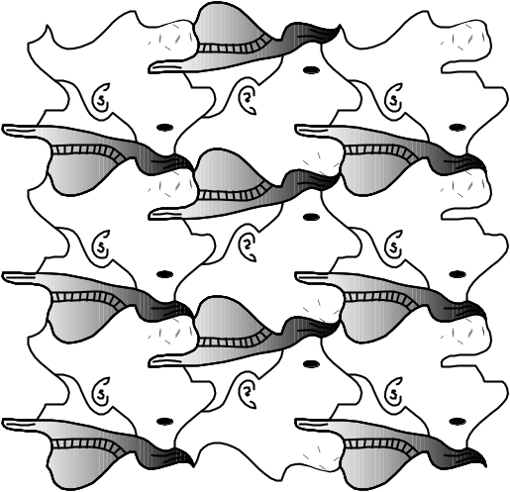

(b) 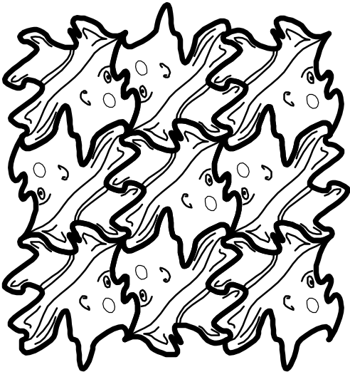

(c) 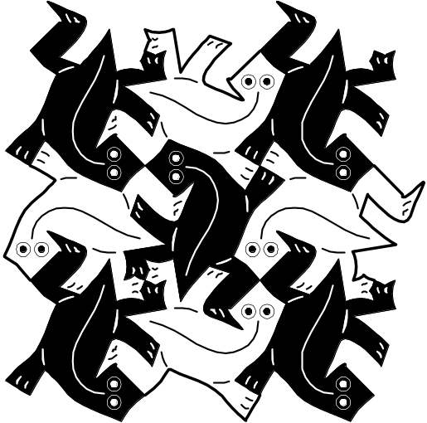

CD Problem – Mira
Name:____________________

- (11 points) Using a mira, construct a line which is parallel to line m and passes through the point A.

Note: Do the construction and then clearly describe the process that you used.

Describe:

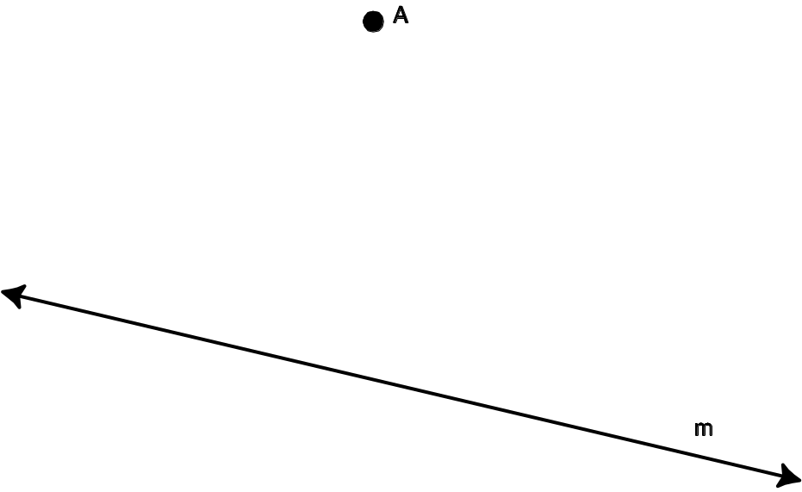
CD Problem – Straight Edge and Compass

Name:______________________

- (11 points-C) Using a straight edge and compass, find the point D so that ABCD forms a parallelogram.

First do the construction and then describe your steps.

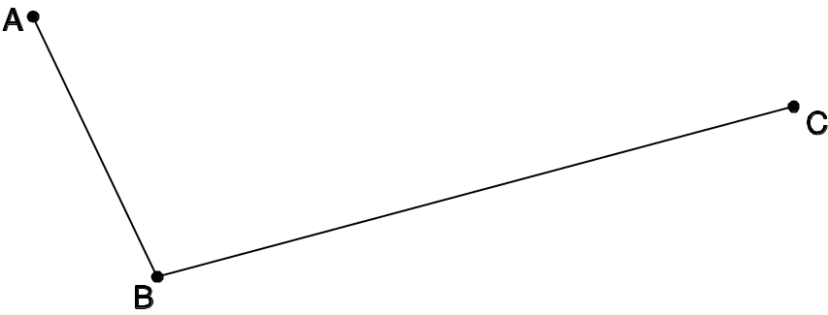

Describe:

CD Problem – Straight Edge and Compass

Name:_______________________

- (11 points) Using a straight edge and compass, locate a point A’ which is the reflection of point A through the line m.

Note: Do the construction and then clearly describe the process that you used.

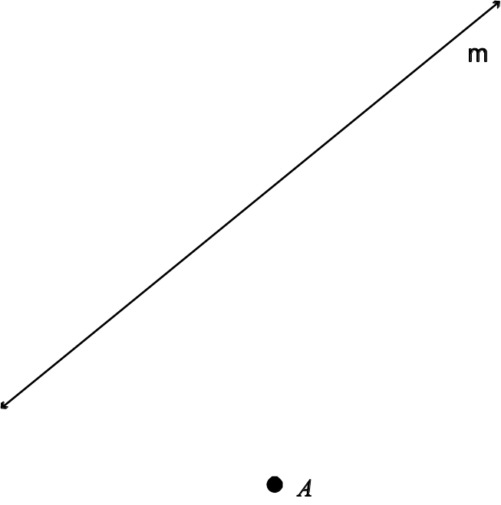

Describe:

CD Problem – Paper Folding

Name:______________________

- (11 points-C) Use paper folding to find the center of the circle which goes through points A, B and C. Use a compass to draw this circle.

Describe the process that you used to find the circle going through the three points.

Describe:



