MATH 3403 – Geometric Structures – Exam II
October 2003
Name:________________________________

1. (14 points) Consider the two lines pictured:

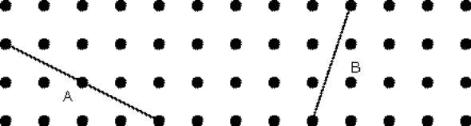

First figure the slopes for the two lines:

Line A: Line B:
Slope as ratio:____________ Slope as ratio______________

Slope as decimal:_________ Slope as decimal____________

Slope as percent:__________ Slope as percent____________

Next figure the lengths for the two lines:

Line A: Line B:
Length as a square root: Length as a square root:

Length as a decimal: Length as a decimal:

2. (6 points) A line segment AB is given below. Circle two points and mark them C and D to make a square with AB a diagonal.

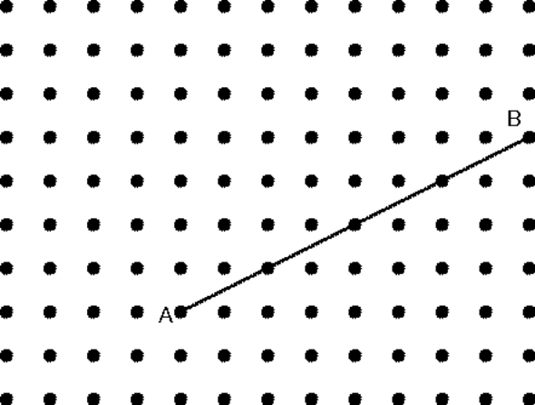

3. (6 points) The two figures drawn below are similar. Inside of each figure write the area.

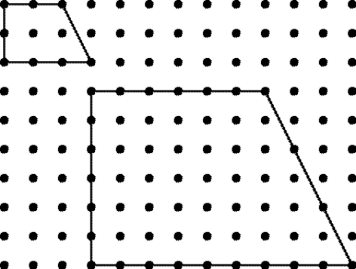

(a) What is the scale factor going from the smaller
figure to the larger?

(b) What is the area factor going from the smaller
figure to the larger?

(c) Describe how the area factor and the scale factor
are related. Your description:

4. (6 points) When Marilyn cooks at home, one box of brownie mix makes brownies of just the right height. If she uses her mother’s pan, which has dimensions twice the dimensions of her pan, how many boxes of brownie mix will she have to buy to make the same thick chewy brownies?

5. (6 points) Last year Robert bought his girlfriend Louise a heart-shaped box of chocolates for Valentine Day. Since they both like chocolates they finished it off in 1 day. If he wants to make the chocolate last all weekend (2 days) how much larger should the dimensions of the box be? (Think about twice as much candy in the same number of layers.)

6. (6 points) Figure out the perimeter of the following figure. Write your answer two ways: (a) as a sum of square roots and (b) as a decimal.

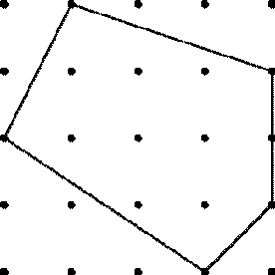

(a) As a sum of square roots:

(b) As a decimal:

7. (6 points) Make a line which has a length of 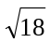joining two points of this Geoboard.

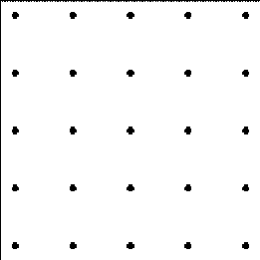

8. (6 points) Figure out the length of the sides of these right triangles which are marked with a “?”. Show your work.

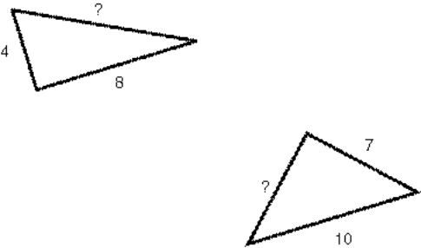

9. (6 points) By each of the three figures given below write CC for congruence condition if enough information is given to determine the figure. If not enough information is given write NOT CC.

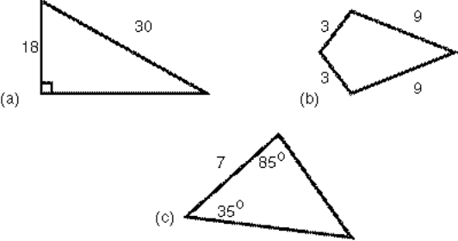

10. (8 points) Consider this figure.

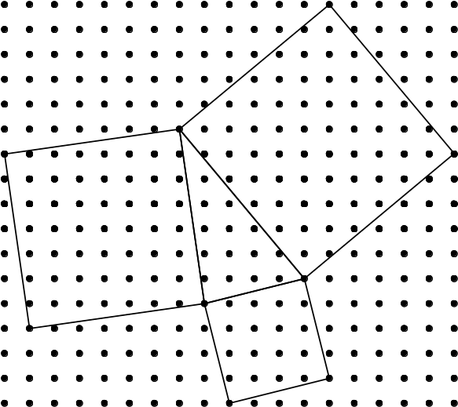

(a) (2 points) Is this triangle of squares a right triangle
of squares (Yes or No)?

(b) (6 points) give two different reasons for your
answer. Show calculations to support your reasons.
Reason 1:

Reason 2:

11. (6 points) The base of an 8-foot ladder is placed 2 feet away from a wall. How far up the wall does the ladder reach? Show all work and include a diagram in your work.

Four Step Problem
Name:___________________________________
12. (12 points)

Official Definition: A parallelogram is a quadrilateral in which opposite sides are equal.

Property: For official parallelograms, alternate interior angles for a diagonal are congruent.

Note: You only need to show for one diagonal. the same presentation will apply to the other diagonal as well. Alternate interior angles for the diagonal are labeled x and y in the figure below.

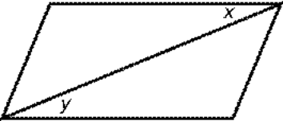

Step 1

Step 2

Step 3

Step 4

Four Step Model
Step 1: Mark given information on figure: official definition, constructions, related definitions, earlier results.

Step 2: Draw and identify apparently congruent triangles.

Step 3: Cite and fully apply CC to triangles.

Step 4: Apply CPCT for results needed for the property.

CD Problem – Straight Edge and Compass
Name:______________________________

13. (12 points) Two sides and the included angle are given below. Using a straight edge and compass, make a triangle out of the given information. Begin by copying segment AB onto line l below.

First carry out your construction. Then write out a step by step description of the process that you use.



