File: Probs-Ch5.doc
Chapter 5:

Problems: Areas

This file contains a selection of problems related to Chapter 5. These may be used when making up exams.

Geoboard Area Methods
- These are some of the ways we have been finding areas of geoboard figures:
Take-away Cut-up
Julie’s way (triangles) Base height
½ (base height)
Four different geoboard figures are given below. You are to work out the area of each of these figures using a different method on each one. Be sure to name the method you use and fully show your work along with any needed explanation.

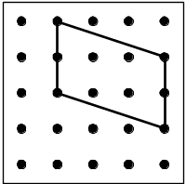
        - Do this by some method.
Method Name:
Show method:

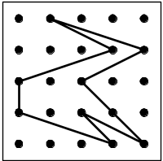
        - Use another method.
Method name:
Show method:

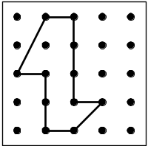
        - Use a different method.
Method name:
Show method:

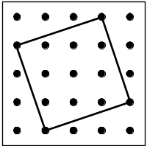
        - Use a different method.
Method name:
Show method:

- These are some of the ways we have been finding areas of geoboard figures:
Take-away Cut-up
Julie’s way (triangles) Base height
½ (base height)
Three different geoboard figures are given below. You are to work out the area of each of these figures using a different method on each one. Be sure to name the method you use and fully show your work along with any needed explanation.
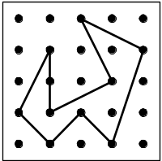
(a) Do this by some method.
Method name:
Show method:

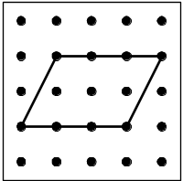
(b) Use another method
Method name:
Show method:

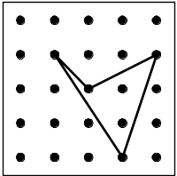
(c) Use a different method.
Method name:
Show method:

- Illustrate four different ways to find the area of this figure.

Method 1:___________________

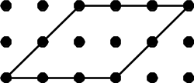

Method 2:___________________

Method 3:____________________

Method 4:____________________

_________________________________________________
Alternate Graphics:
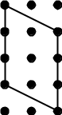
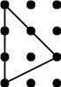
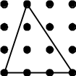
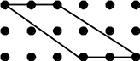
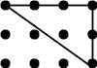

- Place an “x” in the box to make which method works for the different shapes below.

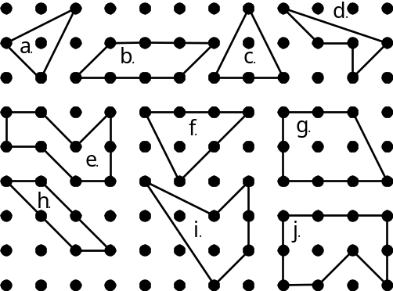

 | a | b | c | d | e | f | g | h | i | j
Cut-Up
Julie’s
Take Away
½ base × height
base × height

- For the given figure, write two methods that work to find the area, and one method that does not work to find the area. Demonstrate these methods on the figure.

Method 1:____________________
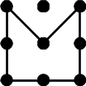

Method 2:____________________

Method that doesn’t work:______________
Why won’t the method work on this figure?

_________________________________________________Alternate Graphics:
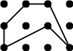
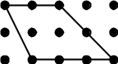

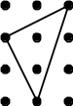
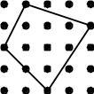
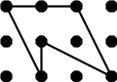

- Find the area of the following geoboard figure.

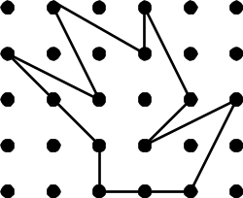

_________________________________________________
Alternate Graphics:
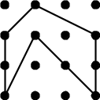
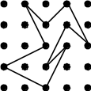
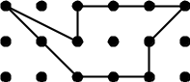

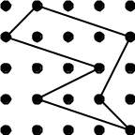
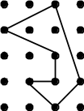
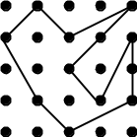

General Area Problems

- This figure shows the lengths of the two diagonals of a rhombus.

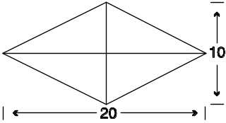

What is the area of this rhombus? Show your work!

- The short diagonal of a kite is 10 units long and the long diagonal is 20 units long. They cross five units from the end on the long diagonal as pictured.
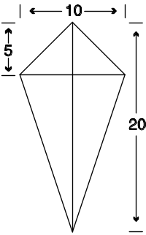

What is the area of this kite? Show your work!

- Find the area of this trapezoid.

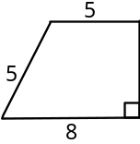

________________________________________________
Alternate Graphic:
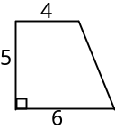

- Find the area of this quadrilateral.
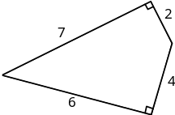

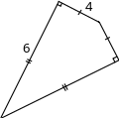
_________________________________________________Alternate Graphic:

- The diagonals of a rhombus are 4 and 5. Work out the area of the rhombus.

- The legs of a right triangle are 3 and 7. What is the area of the triangle? (Show your work!)

- If a small can of paint covers 30 square feet, how many cans are needed to cover a wall that is 20 ft by 9 ft?

Miscellaneous Problems

- Is it possible to make a geoboard figure with area 1 ¾?
If so, draw the figure.

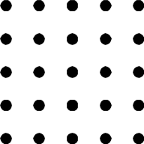

- Jacob still didn’t understand Julie’s way to find areas. He said, “When I used the take-away method, I got an area of 13 ½, but when I cut it up into triangles, I got 26÷2=13.” What is Jacob doing wrong? Write down your explanation.

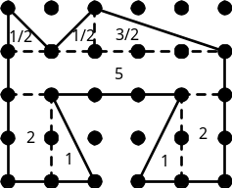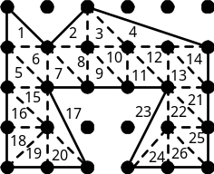

Your Explanation:

- Next to the picture, write in the coordinates of the parallelogram in the spaces provided. Then find the area using the “parallelogram method”. Be sure to show your work!

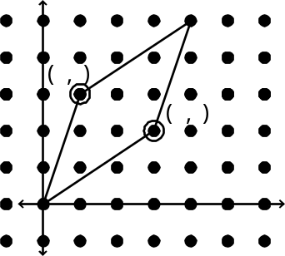

True or Not

***Teacher Note: Because it is hard to ask this type of question over the material covered in this chapter, you may want to mix these “true or not” and “possible” problems with ones from other chapters. ***

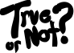
- For the following statements
  - If true, simply write true, or
  - If false, write false and draw an example showing the statement is false.

(A) If the area of a figure is 1, then it must be a unit square.

(B) The area of a geoboard figure is always a whole number.
Possible or Not

- For each of the following statements, decide if it is possible or not.
- If it is possible, write POSSIBLE and draw a picture.
- If it is not possible, write NOT and give a reason.

A geoboard figure with area 1/3.


A square on a geoboard with area 2.

