File: Probs-Ch1.doc
Chapter 1:

Problems: Polygons and Angle Relationships

This file contains a selection of problems related to Chapter 1. These may be used when making up exams.

Angle Sum Problems
  - What is the angle sum for the following polygon? Show your reasoning!



_________________________________________________Alternate Figures:
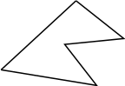



- A Polygon has an angle sum of 1260. How many sides does the polygon have? Show your reasoning!

Solving Angle Problems
- In the two figures below, give the value of the angles marked with a question mark “?.” Be sure to show your work!
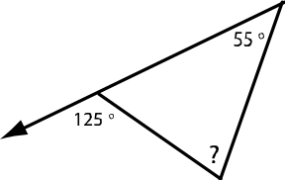
a)

b)
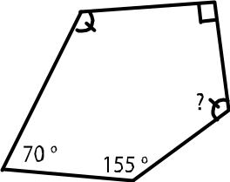

_________________________________________Alternate Figures:
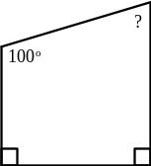
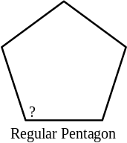
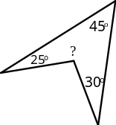

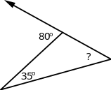
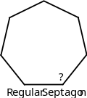
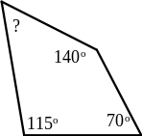

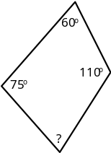
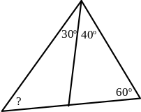
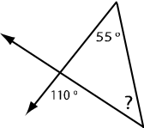

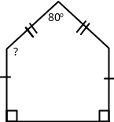
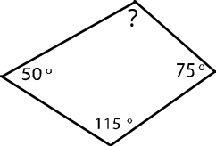

- What is angle marked a in this figure:

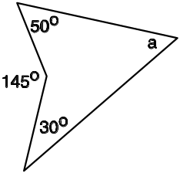

- What is the angle marked a in this figure:
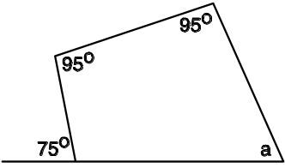

- In the figure below for each of the angles marked with a letter, (i) give the value of the angle and (ii) give a reason.
Acceptable reasons include:
“alternate interior angle to something”
“corresponding angle to something”
“vertical angle to something”
“supplementary angle to something” or
“the angle sum is something.”

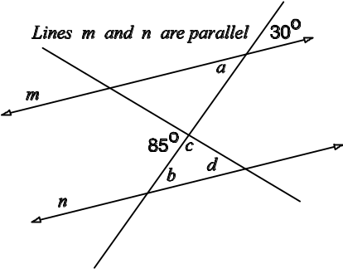

- The value of a is:
The reason is:

- The value of b is:
The reason is:

- The value of c is:
The reason is:

- The value of d is:
The reason is:

_________________________________________________Alternate figures:
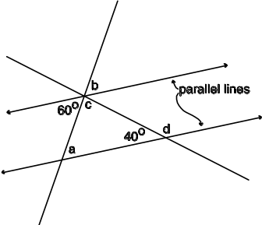
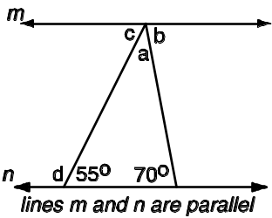

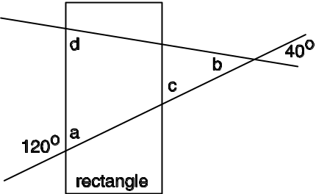

- What is the value of the angle marked with an x? Show your work!

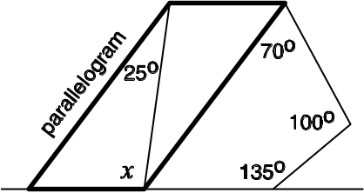

____________________________________________Alternate Graphics:

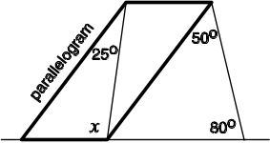

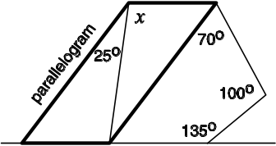

Invent/Think Problems
- The class was discussing angle sums. Most of the students knew that a quadrilateral had an angle sum of 360º. However, Annie said, “Something bothers me! When I divided the quadrilateral up into triangles I got an angle sum of ”
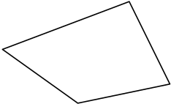
  - In the quadrilateral below indicate how you suspect that Annie must have been dividing up the quadrilateral.

  - How would you explain to Annie the way that a polygon needed to be divided up in order to get the correct angle sum?
Your Explanation:

- Mary noticed that if all of the angles of a triangle are the same, then the sides are also the same length. Is this true of a hexagon? If all the angles of a hexagon are 120, then must all of the sides be the same? If you agree, write “yes,” but if you disagree, draw a picture representing why this does not have to be true.

- A parallelogram is shown below with the sides extended.
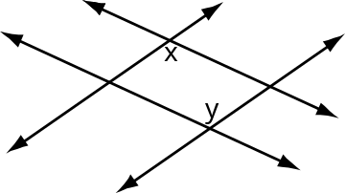

Using the ideas of “alternate interior angles” and “corresponding angles,” create a line of reasoning that shows that angles x and y are the same. It may help you to label the angles that you use in your reasoning.
Your Reasoning:

Greedy Triangle
- The Greedy Triangle visited the Shape-Shifter four times.
a) What was the shape of greedy after the fourth visit?

b) What was Greedy’s angle sum after the fourth visit?

Greedy then visited the Shape-Shredder. c) How many brothers and sisters were there after the visit to the Shape-Shredder (including Greedy)?

Possible or Not

- For each of the following statements, decide if it is possible or not.
- If it is possible, write POSSIBLE and draw a picture.
- If it is not possible, write NOT and give a reason.

a) A triangle with two right angles.

b) A regular octagon with one angle equal to 100˚.

c) A polygon with an angle sum equal to 560.
_________________________________________________Alternate Statements:
A concave hexagon.

A quadrilateral with exactly three right angles.

A regular pentagon that is concave.

A pentagon with exactly one line of symmetry.

True or Not


- For the following statements
  - If true, simply write true, or
  - If false, write false and draw an example showing the statement is false.

If the angle sum is 360, the polygon must be a quadrilateral.

Every angle sum of a polygon must be a multiple of 180.

For a polygon, if the sides are all equal, the angles must all be equal too.

If the angles of a polygon are all equal, then the sides must all be equal.

All polygons can be cut up into triangles.

For a triangle, if all of the sides are equal, then all of the angles are equal.

