File: E04f-F.doc
Geometric Structures – Final – Fall 2004
Name:_______________________

- (12 points) Using the code table below, identify the symmetry type of these borders.

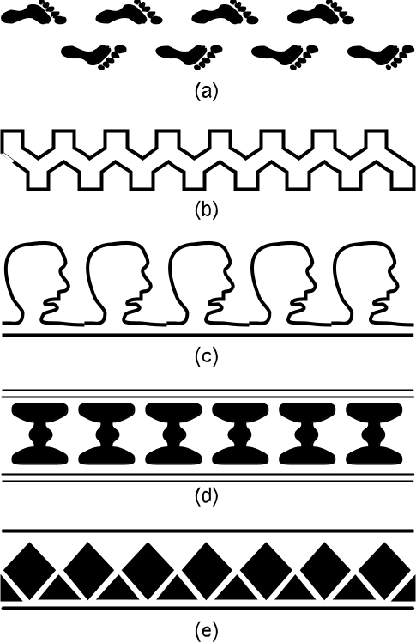

Code for Border Patterns
First | Second
m crossline sym. | m centerline sym.
1 no crossline sym. | g glide reflectional sym.
 | 2 half-turn symmetry
 | 1 no additional sym.

- (6 points) Four pairs of congruent figures are given below. Indicate which of the four types of actions relate the two copies by writing translation, rotation, reflection or glide reflection.
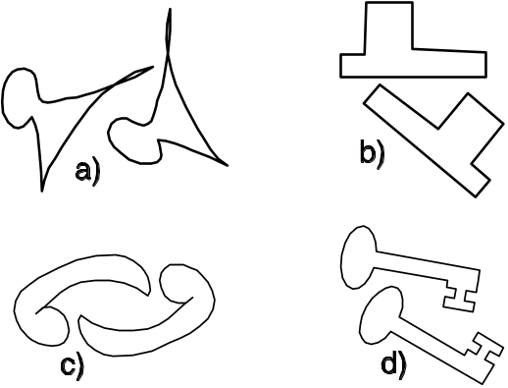

- (8 points) For the two geoboards shown below you are to figure the areas and describe the method you used. Two different methods need to be used.

- Name Method Used:

Describe the method:
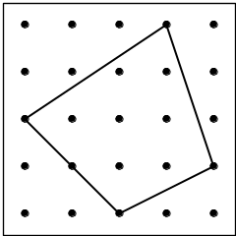

- Name Different Method Used:

Describe the method:
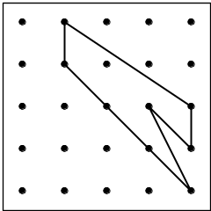

- (4 points) What is the measure of the angle marked with a question mark? Show your work!

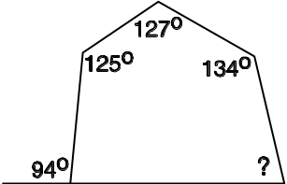

- (8 points) Figure out the value of the angles marked with a question mark given below.

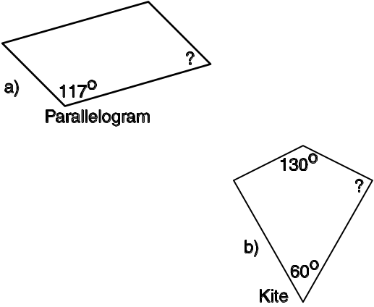

- (8 points) In the figure below for each of the angles marked with a letter, (i) give the value of the angle and (ii) give a reason.

Acceptable reasons include:
“alternate interior angle to something”
“corresponding angle to something”
“vertical angle to something”
“supplementary angle to something” or
“the angle sum is something.”
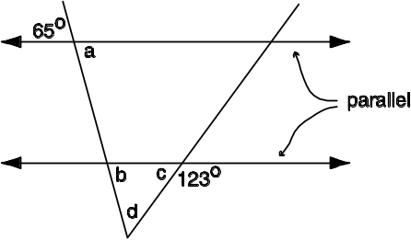
- The value of a is:
The reason is:

- The value of b is:
The reason is:

- The value of c is:
The reason is:

- The value of d is:
The reason is:
- (8 points) Figure out the lengths of the sides marked x and y in the two figures below. Be sure to show your calculations!

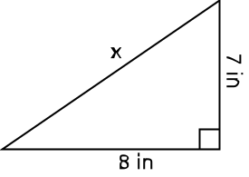

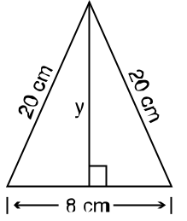

- (6 points) Find the perimeter of the geoboard figure given below. Express your answer in the two ways asked for.
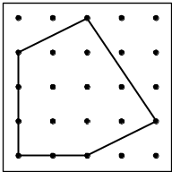

- The perimeter expressed as a sum of square roots.

- The perimeter expressed as a decimal.

- (6 points) What is the volume of the barn shown below which is 24 feet long and whose ends are shaped like an isosceles trapezoid with dimensions as shown?

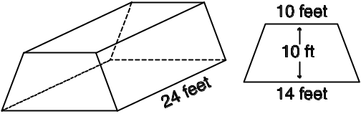

- (7 points) There are two related parts to this problem

- What is the area of the trapezoidal shaped region on the geoboard given below?
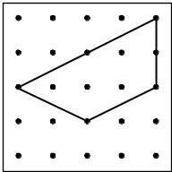

- If the trapezoid shape from part (a) is the base of a pyramid which is 3 units tall (see figure below), what will the volume of this pyramid be?
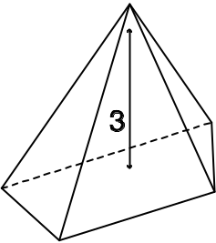

- (6 points) Five geoboard figures are given below. For each of the properties below list the letters of the figures which satisfy the property.

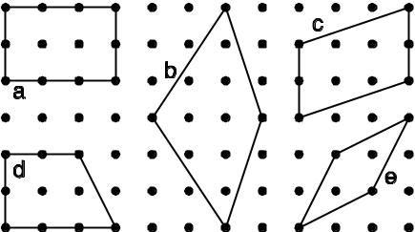
  - Property: The diagonals are perpendicular.
Letters:

  - Property: Opposite angles are the same.
Letters:

  - Property: The diagonals bisect the corner angles.
Letters:

- (6 points) What is the area of the dark portion of the following figure where the larger circle has radius 12 centimeters and the seven smaller and equal circles just fit inside?
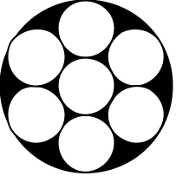

- (4 points) What is the scale factor going from Triangle 1 to Triangle 2 as shown below?
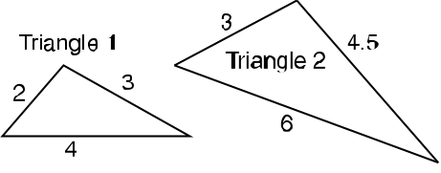

- (4 points) What is the length of the side marked with an x?
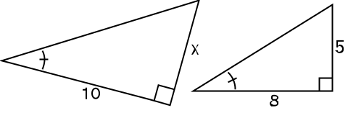

- (3 points) Which of the lines a, b, c, or d is perpendicular to line m?

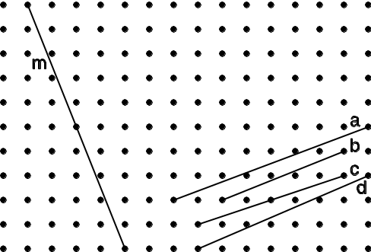

- (6 points) One application of fertilizer to a certain field requires 500 pounts of fertilizer. If the dimensions of the field are doubled, how many pounds of fertilizer would be needed for an application at the same rate to the enlarged field?

- (12 points) Analyze each of the Escher style tessellations given below. For each design, indicate the Heesch type.

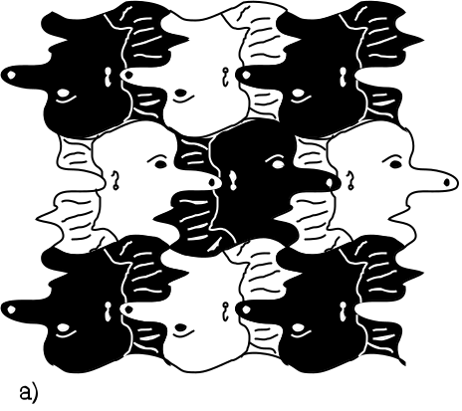

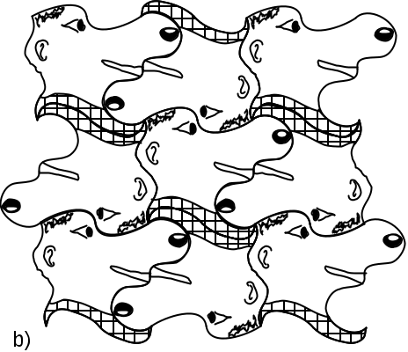

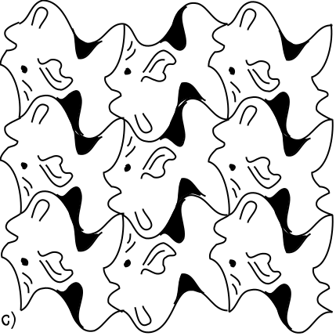

CD Problem – Mira
Name:____________________

- (9 points) Using a mira, construct the incenter of the triangle given below. To check your construction, use a compass to draw the inscribed circle.

Note: Do the construction and then clearly describe the process that you used.

Describe:

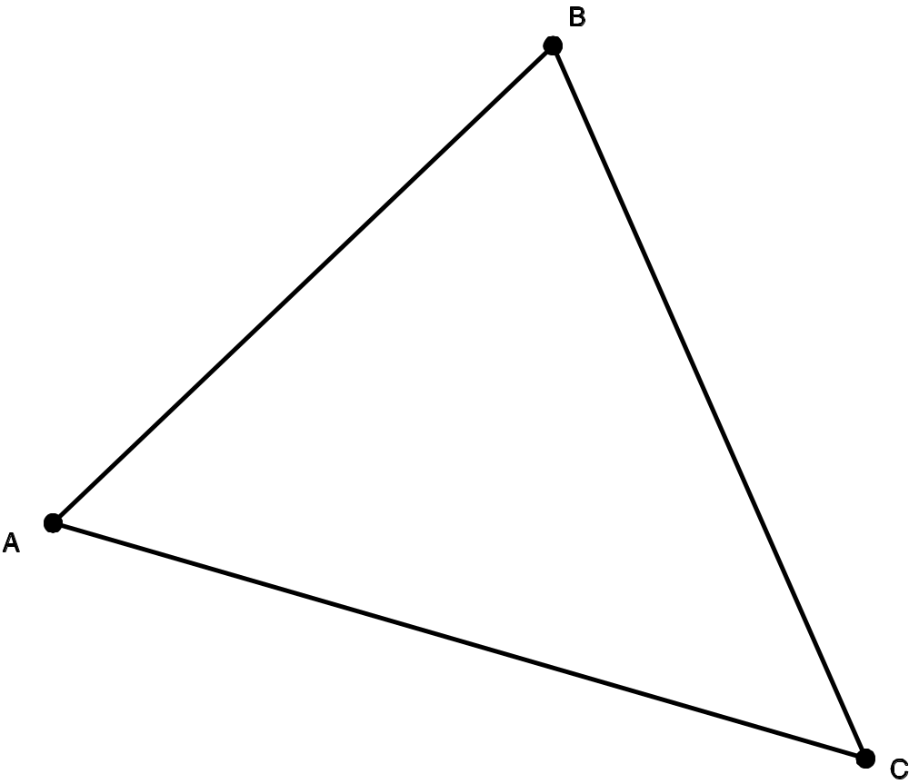
CD Problem – Paper Folding

Name:______________________

- (9 points) Using paper folding, fold an equilateral triangle so that segment AB below is one side.

First do the construction and then describe your steps.

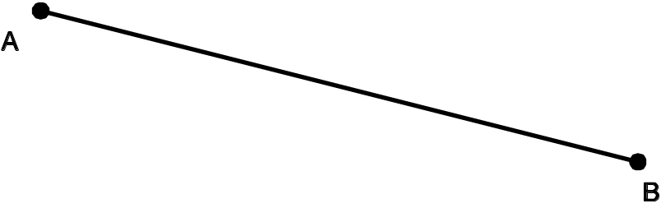

Describe:

CD Problem – Straight Edge and Compass

Name:_______________________

- (9 points) Using a straight edge and compass, construct a triangle so that the three lengths given below are congruent to the three sides of the triangle and the side corresponding to AB is on line m.

Note: Do the construction and then clearly describe the process that you used.

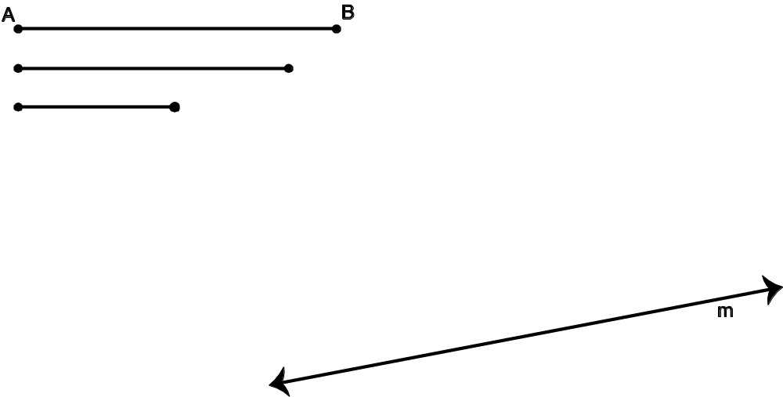

Describe:

CD Problem – Straightedge and Compass

Name:______________________

- (9 points) Using a straightedge and compass, locate a fourth point D so that ABCD forms a kite.

Describe the process that you used.

Describe:



