Chapters 1, 2, 3, 5 File: E04f-1.doc
Geometric Structures – Exam I – Fall 2004
Name:___________________

- (15 points) Three copies of a geoboard figure with area 4 ½ are shown below. For each of these a method for figuring the area is given. You are to use the figure to illustrate the method named. Be sure to fully show the method so that it will be clear how you are doing it.

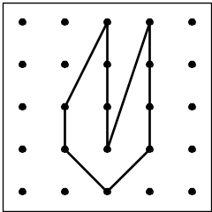
  - Method: Cut-Up

Show method:

  - Method: Take-away

Show method:

  - Method: Julie’s Way

Show method:

- (6 points) What is the area of the trapezoid shown below? Show your work!
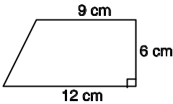

- (6 points) Three kite-shaped figures are shown below. Each of these kites is made of a 4 unit stick and a 6 unit stick.

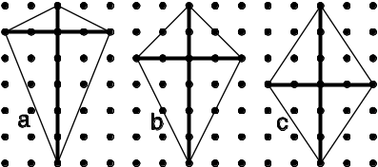

  - Carefully work out the area of each of these kites and write the value by each of them.

  - Make a guess or conjecture about an easy way to figure the area of a kite. Clearly and carefully write out your conjecture.
Your Conjecture:

- (5 points) Based on the information given, are lines m and n parallel? Clearly express your reasoning.
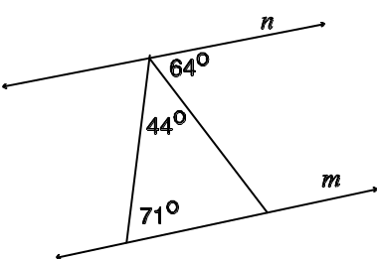
Parallel? (Circle one) YES or NO
Reasoning:

- (5 points) Figure out the value of the angle marked with an a. Show your work!

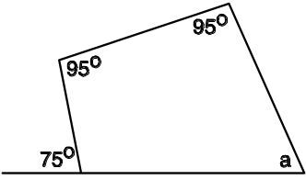

- (5 points) What is the value of the angle marked with a question mark? Be sure to show your work!

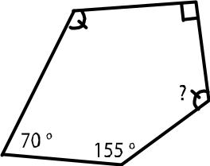

- (12 points) In the figure below for each of the angles marked with a letter, (i) give the value of the angle and (ii) give a reason.
Acceptable reasons include:
“alternate interior angle to something”
“corresponding angle to something”
“vertical angle to something”
“supplementary angle to something” or
“the angle sum is something.”

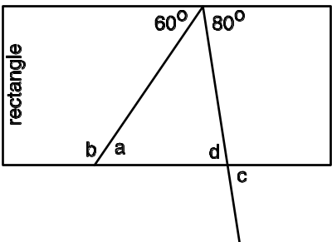
- The value of a is:
The reason is:

- The value of b is:
The reason is:

- The value of c is:
The reason is:

- The value of d is:
The reason is:

- (5 points) Types of quadrilaterals are listed below. Circle the names of the quadrilaterals which are special cases of a trapezoid.
Squares Parallelograms
Rectangles Kites
Rhombuses Isosceles Trapezoids

- (12 points) Five figures are given on the geoboard below. For each of the properties below list the letters of the figures which satisfy the property.
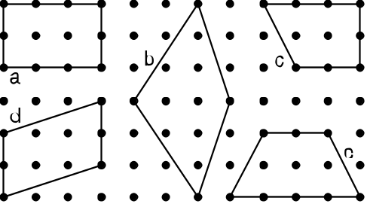
  - Property: The diagonals are congruent.
Letters:

  - Property: Opposite angles are the same.
Letters:

  - Property: The diagonals bisect each other.
Letters:

- (9 points)  For each of the following statements, decide if it is possible or not.
  - If it is possible, write POSSIBLE and draw a picture.
  - If it is not possible, write NOT and give a reason.

  - A parallelogram with one angle of 70º and another of 100º.

  - A trapezoid with just one pair of equal sides.

  - An equilateral right triangle.

CD Problem – Paper Folding
Name:_____________________
- (10 points) Using paper folding, construct an isosceles right triangle with the line segment AB as a leg.

Note: Do the construction and then clearly describe the process that you used.

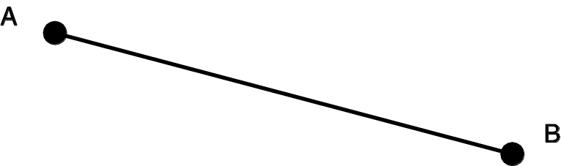

CD – Problem – Paper Folding
Name:______________________
- (10 points) Using paper folding, construct the circumcenter of the triangle given below. Use a compass to check your procedure by drawing the circumscribed circle.

Note: Do the construction and then clearly describe the process that you used.



