MATH 3403 – Geometric Structures – Final Exam
December 2003
Name:________________________________

1. (9 points) Analyze each of the Escher style tessellations given below. For each design, indicate the Heesch type.
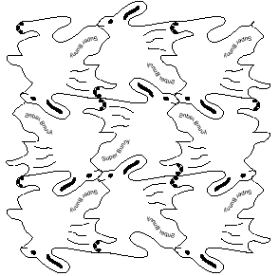

(a)

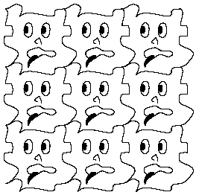

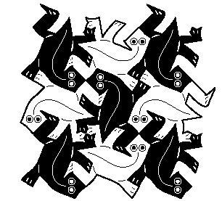
(b)

(c)

2. (8 points) For each of the tessellation prototiles given below, identify the Heesch type.
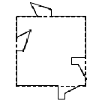
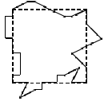
(a) (b)
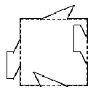
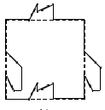
(c) (d)

3. (8 points) Several figures are given below.

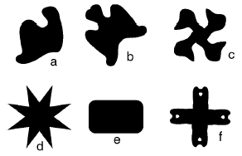

- Which figures are symmetric?(list letters)

- Which figures have bilateral symmetry?

- Which figures are fold and cut?

- Which figures are double fold and cut?

4. (12 points) Here are some ways we have used to find the areas of Geoboard figures:

Take-away Cut-up
Julie’s way (triangles) Base x height
½(base x height) Internal pegs + 1
Pick’s Formula

Use a different method on each figure below to find the area of the figure. State which method you are using and show clearly how you found the area. Note: Be sure to use 4 different methods.

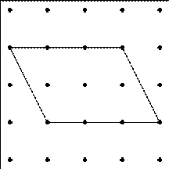
(a) Method 1:

(b) Method 2:
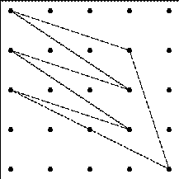

(c) Method 3:
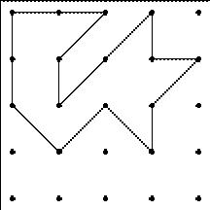

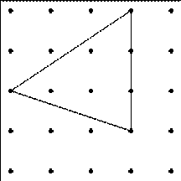
(d) Method 4:

5. (5 points) Max is planning to enlarge his square cattle pasture so that the new fence encloses two times the area of the present pasture. He wants the pasture to remain square. The original fence is 200 feet long on each side. How long should one side of the new fence be?

6. (6 points) Figure out the perimeter of the following figure. Write your answer two ways: (a) as a sum of square roots and (b) as a decimal.

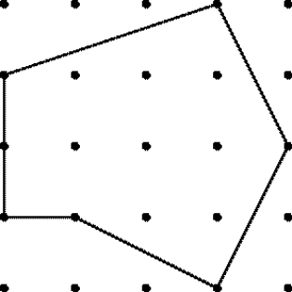

(a) As a sum of square roots:

(b) As a decimal:

7. (9 points) By each of the three figures given below write CC for congruence condition if enough information is given to determine the figure. If not enough information is given write NOT CC.

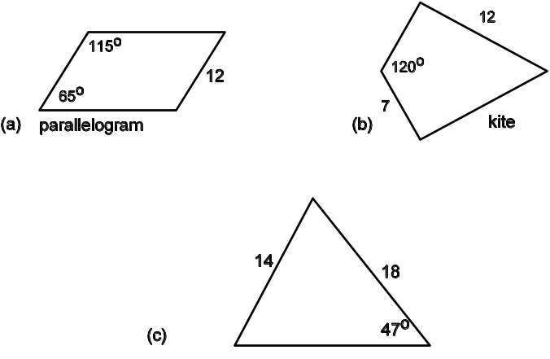

8. (12 points) Using the code table below, identify the symmetry type of these borders.

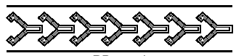

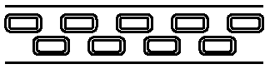

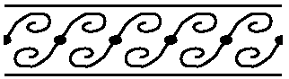

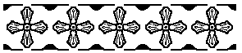

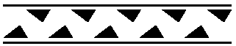

Code for Border Patterns
First | Second
m crossline sym. | m centerline sym.
1 no crossline sym. | g glide reflectional sym.
 | 2 half-turn symmetry
 | 1 no additional sym.

9. (4 pts) Draw a mandala that has symmetry type D₃. If the mandala has lines of reflectional symmetry, sketch them also, or state no lines of symmetry.

10. (9 points) Three statements are given below. After each statement either
- circle definition if the statement is a definition, or
- circle property if the statement is a property but not a definition. Also give an example to show the property is not a definition.

(a) An isosceles trapezoid is a quadrilateral that has a line of symmetry. Property or Definition?

(b) A parallelogram is a quadrilateral that has equal opposite sides. Property or Definition?

(c) An isosceles trapezoid is a trapezoid that has a line of symmetry. Property or Definition?

11. (8 points) Find the sum of the interior angles for this polygon. Show your work.

(a) What is the measure of the angle marked ? in this
regular polygon?

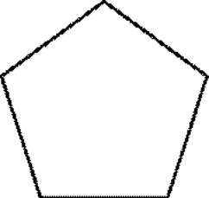

?

(b) Find the sum of the interior angles for this polygon.

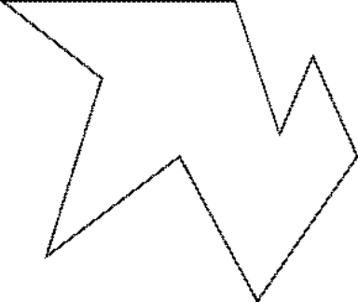

CD Problem –MIRA
Name:______________________________
13. (10 points) The two figures given below are related by a rotation. Using a mira, construct the center of this rotation.

Note: Do the construction and then clearly describe the process that you used.

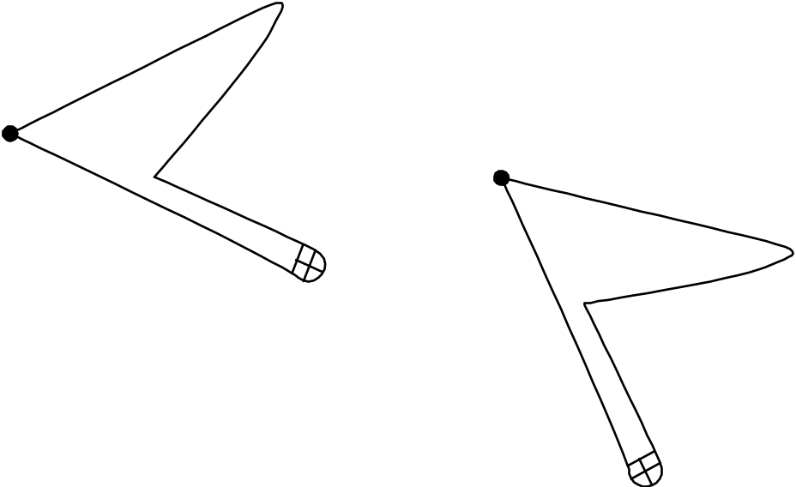

CD Problem –MIRA
Name:______________________________

14. (10 points) Using a Mira, find the circumcenter of this triangle. Then with a compass draw the circumscribing circle for the triangle. Finally, describe fully the process you used to construct the circumcenter and circumscribing circle.

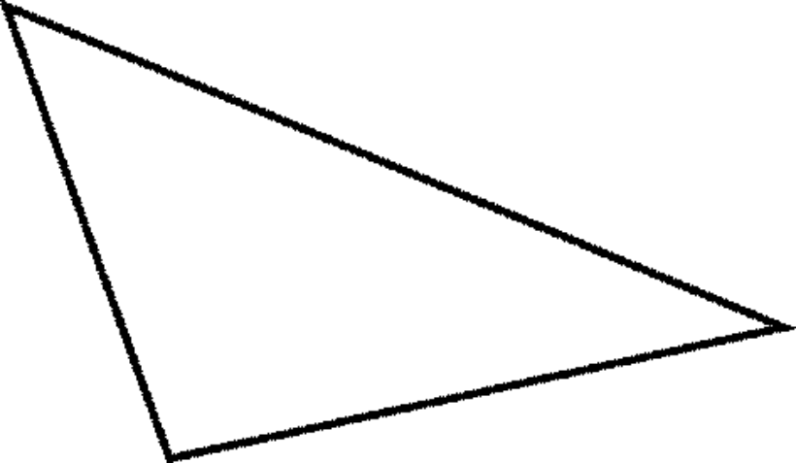

Definitions to Properties – Four Step Model
Name:_________________________________
12. (10 pts)
Official Definition: A kite is a quadrilateral in which one of the diagonals bisects the angles at both ends.

Property: For an official kite, there are two pairs of adjacent congruent sides (ASA).

Step 1

Step 2

Step 3

Step 4

Four Step Model
Step 1: Mark given information on figure: official definition, constructions, related definitions, earlier results.

Step 2: Draw and identify apparently congruent triangles.

Step 3: Cite and fully apply CC to triangles.

Step 4: Apply CPCT for results needed for the property.

CD Problem – Straight Edge and Compass
Name:______________________________

15. (10 points) Two sides and the included angle are given below. Using a straight edge and compass, make a triangle out of the given information. Begin by copying segment AB onto line l below.

First carry out your construction. Then write out a step by step description of the process that you use.

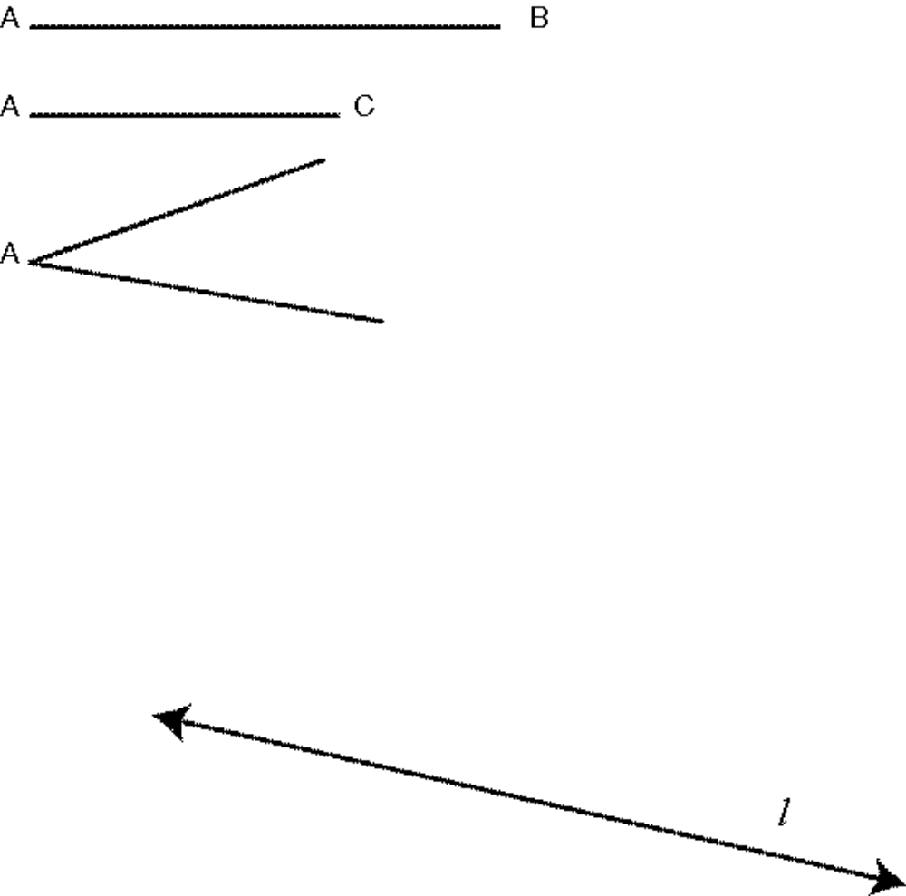

CD Problem – Folding
Name:______________________________

16. (10 points) Using folding construct a line parallel to line segment AB through point P.

First carry out your construction. Then write out a step by step description of the process that you use.

P .

B

A

