MATH 3403 – Geometric Structures – Exam III
November 2003
Name:________________________________

1. (5 points) In the triangle given below, use a Mira to carefully draw and identify the altitude that goes through the vertex labeled A.

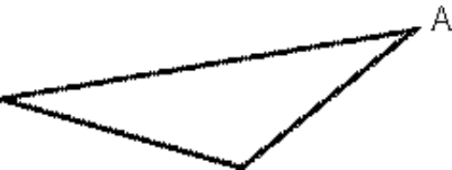

2. (5 points) Sketch an example of a triangle that has an altitude that coincides with a side of the triangle.

What kind of triangle is this?

How many altitudes of the triangle coincide with sides of the triangle? Give a brief reason for your answer to this part.

3. (4 points) For each of the following figures, write “1” if it is one-sided and write “2” if it is two-sided.

a. ♣ b. ®
c. ϑ d. Ξ

4. (4 points) For the following pairs of figures, write the letter S or O underneath to indicate if the orientation is the Same or Opposite.
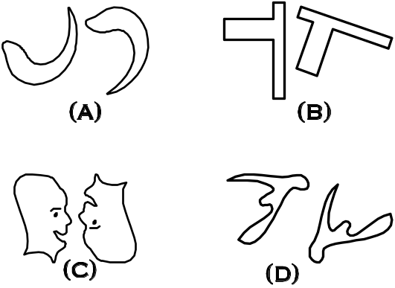

5. (8 points) Pairs of congruent figures are given below. For each pair, indicate by which of the four types of transformations the two copies are related (translation, reflection, rotation or glide reflection).

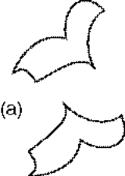
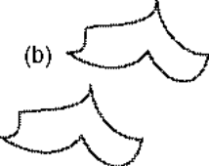

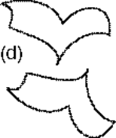
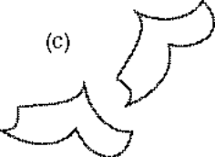

6. (5 pts) A rectangle is given below which can be used to generate a border by repeated translation both left and right. Draw a figure in this rectangle so that the resulting border would be of type m1.



7. (4 points) The two figures below are related by a rotation. Find the center of rotation for the two figures.



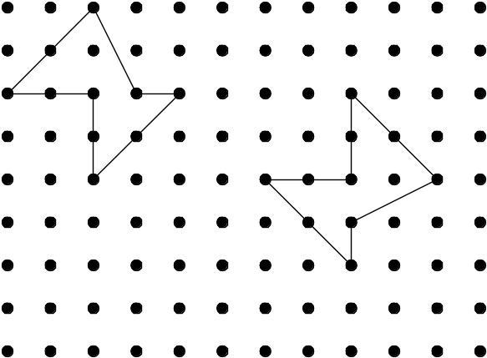

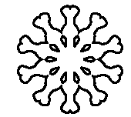

8. (15 points) Using the code table below, identify the symmetry type of these borders.



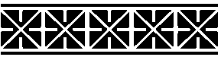

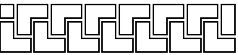

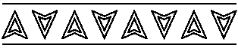



Code for Border Patterns
First | Second
m crossline sym. | m centerline sym.
1 no crossline sym. | g glide reflectional sym.
 | 2 half-turn symmetry
 | 1 no additional sym.

9. (18 points) Using the code table below, identify the symmetry type of the following mandalas.


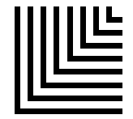

Code for Mandalas
C_{n} | n-fold rotational symmetry  (no reflectional symmetry)
D_{n} | Reflectional symmetry and  n-fold rotational symmetry
D or D₁ | Bilateral symmetry only
N or C₁ | No symmetry

10. (10 points) Give your best answer to these questions.

a) How do you know when a shape is one-sided?

b) What happens to the slope of a line segment that is reflected across a horizontal line?

c) If a mandala has two lines of symmetry, what is the relationship between the two lines of symmetry?

CD Problem –MIRA
Name:______________________________

11. (11 points) The two figures given below are related by a glide reflection. Using a Mira, construct the glide reflection line.
Note: Do the construction and then clearly describe the process that you used.

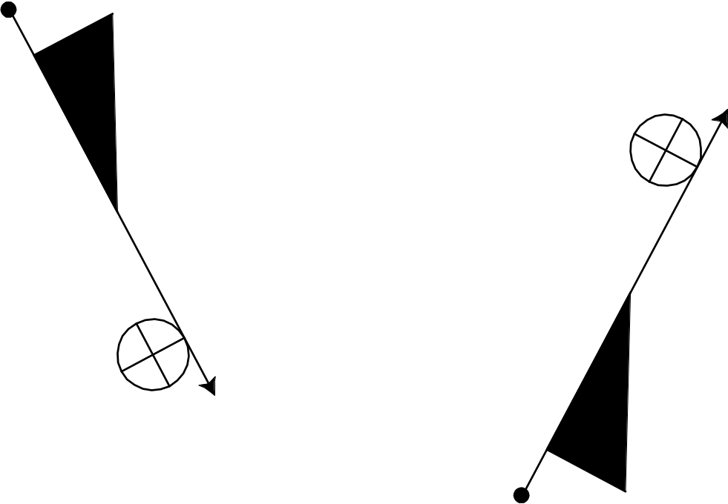

Describe:

CD Problem –MIRA
Name:______________________________

11. (11 points) Using a Mira, bisect all three angles of this triangle.

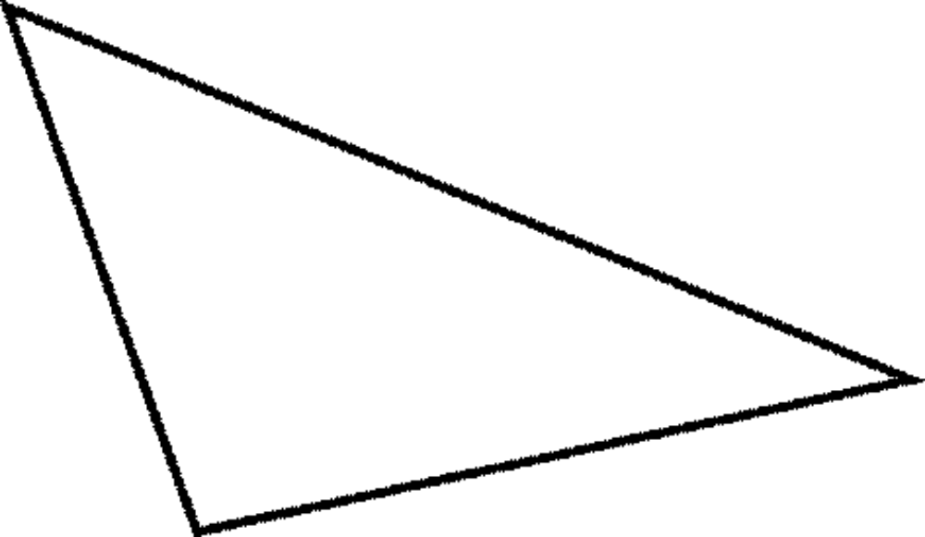

Describe how you bisect an angle with a Mira:

What is the name of the point where the 3 angle bisectors intersect?

